Released: Tuesday 28th May 2019

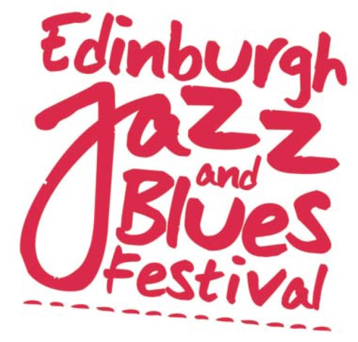

We’ve Got The Blues

Scotland’s biggest celebration of blues music is back with a ten day programme that spans the blues spectrum.

Headlined by GRAMMY winning American Blues star, Kenny Wayne Sheppard, who releases a new album (The Traveller) and appears in Edinburgh as one of only four UK dates. The Louisiana born guitarist and songsmith has sold millions of albums with a host of Top 10 singles and played and recorded with a veritable who’s who of blues: B.B. King and Buddy Guy, Hubert Sumlin, Pinetop Perkins and Noah Hunt. Making this a very special concert the British Guitar virtuoso Matt Schofield opens the show. The Blues Hall-Of-Famer is widely regarded as one of the most innovative guitarists to have emerged in generations, and has been rated in the top ten British blues guitarists of all time by Guitar & Bass Magazine.

American bluesmen Zac Harmon, Melvin Taylor and Popa Chubby make their Festival debuts. Born and raised in the heart of Jackson, Mississippi, Zac Harmon is a true disciple of the Mississippi Blues. From playing guitar and 12-bar blues as a teenager, performing in Mississippi bars, he is headlining Festival across Europe this summer. Melvin Taylor is one of the greatest guitarists in the history of rock, blues, and jazz. He is often referred to as a guitar players guitarist working alongside Stevie Ray Vaughan, Carlos Santana, George Benson, whilst Mick Jagger, Patty LaBelle, Joey Alexander and Joe Bonamassa are all fans. A blues-rock veteran known for his blistering live shows, working-man politics, and fierce Hendrix covers, Popa Chubby delivers smoking live shows described as Motörhead meets Muddy Waters.

Pedal and lap steel guitar ace Roosevelt Collier returns to make his Festival debut as a solo artist after playing with Bokante in 2018. Delivering dirty funk swampy grime,” he was described as “a transcendent talent” (Guitar World). Modern-day country bluesman Alvin Yougblood Hart draws inspiration from his ancestral home in Carrollton, Mississippi whilst also moving effortlessly into Jimi Hendrix territory with swaggering power chords and wah-wah guitar. He plays both solo and with his Trio Muscle Theory.

The Festival has wealth of other international blues attractions. Nashville-based singer-songwriter and guitarist, Stacy Mitchhart who frequently breaks out the cigar box guitars. French duo Max & Veronica passionately play country blues and ragtime, hokum, jug band and rural music from the 20s and 30s on ukuleles, washboard, kazoo, acoustic and resophonic guitars. We’ve already got to know Davina And The Vagabonds, another mid-west export, and we know Davina Sowers’ band is not strictly a blues act, but her rollicking piano playing and singing is soaked in blues, as well as swing, and boogie, early rock n’ roll, and traditional N’Orleans.

Surprisingly, Ian Siegal makes his Festival debut with his award wining band. He started his career as an art school drop out, then an early gig was opening for ex-Stone Bill Wyman’s Rhythm Kings. Since then he has won umpteen awards and toured the world both as a solo performer and with his band.
The Queen of Scottish Blues, Maggie Bell makes two Festival appearances, with a band and in duo with Sandy Tweeddale. Singer, Nicole Smit has been a fixture on the Scottish blues scene working with Blueswater, Cow Cow Boogie, Queens of the Blues, and with The Back Up Crew and she debuts a brand new concert inspired by the great women in blues from Big Mama to Sugar Pie Desanto. Scottish blues star John Bruce presents another brand new project an intriguing double guitar concept, pitching himself against the young English guitar star, Marcus Bonfanti.
Other Scottish favourites include Aberdonian power band Gerry Jablonski Electric Band,
guitarist and vocalist, Jed Potts & The Hillman Hunters, are an electric trio playing blues inspired by 50s and 60s American greats, from Freddie King to Howlin Wolf. A double bill of electric blues, starts with some deep and dirty Mississippi rooted blues-rock from Dixie Fried (guitarist/vocalist Craig Lamie and drummer John Murphy) and classic power trio rock/blues from Full Fat Band. One man blues band Mike Whellans has to be heard to be believed as he plays a host of instruments including 6, 12 string or electric guitars, mouth-harp and drums. The Troublemakers, Baby Isaac, Toby Mottershead, Lights Out By Nine, Dana Dixon, Redfish, Mud In Your Ear with Gary Martin also perform as part of the Festival

Full listings can be found
https://www.edinburghjazzfestival.com/2019-programme/themes/blues-concerts.html

Notes To Editors:
- Launched in 1978, Edinburgh Jazz & Blues Festival is in its 41st year.
- The programme covers jazz, blues, swing, funk, soul and gospel performances – over 130 concerts over 10 days.
- The Festival is supported by The Scottish Government’s Edinburgh Festival Expo Fund, The City of Edinburgh Council

Ticket information
Tickets are available from
- Online at www.edinburghjazzfestival.com
- By phone on 0131 473 2000.
- In person from The Hub, Castlehill, Edinburgh, EH1 2NE.

Social Media
Twitter @edinburghjazz
Facebook facebook.com/edinburghjazzbluesfestival

Instagram @edinburgh_jazz

Hashtag #EJBF2019

